**Assignment 1:**

SELECT

Customers.CustomerName,

CASE

WHEN Orders.OrderID IS NOT NULL THEN 'Yes'

ELSE 'No'

END AS OrderStatus

FROM Customers

LEFT JOIN Orders ON Customers.CustomerID = Orders.CustomerID

GROUP BY Customers.CustomerName, OrderStatus;

**Assignment 2:**

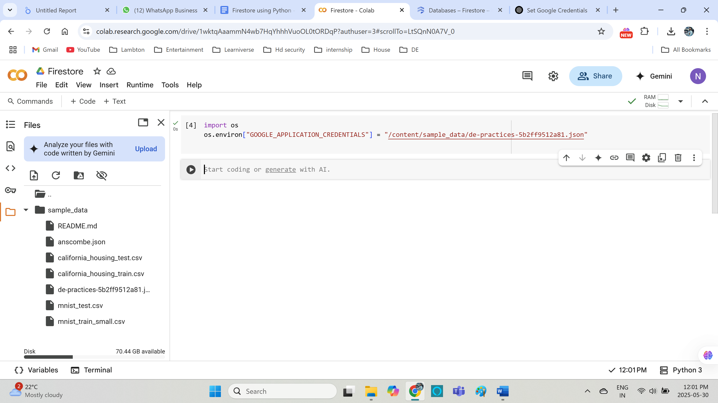

Challenges faced:

When creating database in firestore, I named it as users.  
but in code level, it is searching for default database. So always make sure that you are navigating to correct database.

